Evidence-Based Practice Hexagon Tool
Tool Purpose: The Hexagon Tool helps individuals and organizations systematically evaluate new and existing Evidence Based Practice (EBP) via six broad factors in hopes of attuning to culture and fit of population served. This Hexagon Discussion and Analysis Tool is designed to be used by teams to guide a deeper discussion of each of the six broad components in the Hexagon Tool: Need, Fit, Resources, Evidence, Readiness, and Capacity.

Tool Completion: This tool should be completed by any agency considering implementing culturally humble practices.

Tool Directions: Using the tool, teams are encouraged to use the Discussion and Analysis Tool’s questions to analyze EBPs. Additional lines are included in each section for additional questions identified by the team to address unique needs and contexts. Strengths and gaps are identified so the team can make intentional recommendations regarding the proposed EBP’s ability to meet the need of the population it is intended to serve. This process allows teams to make an informed decision about the organization’s capacity to install and fully implement any EBP.

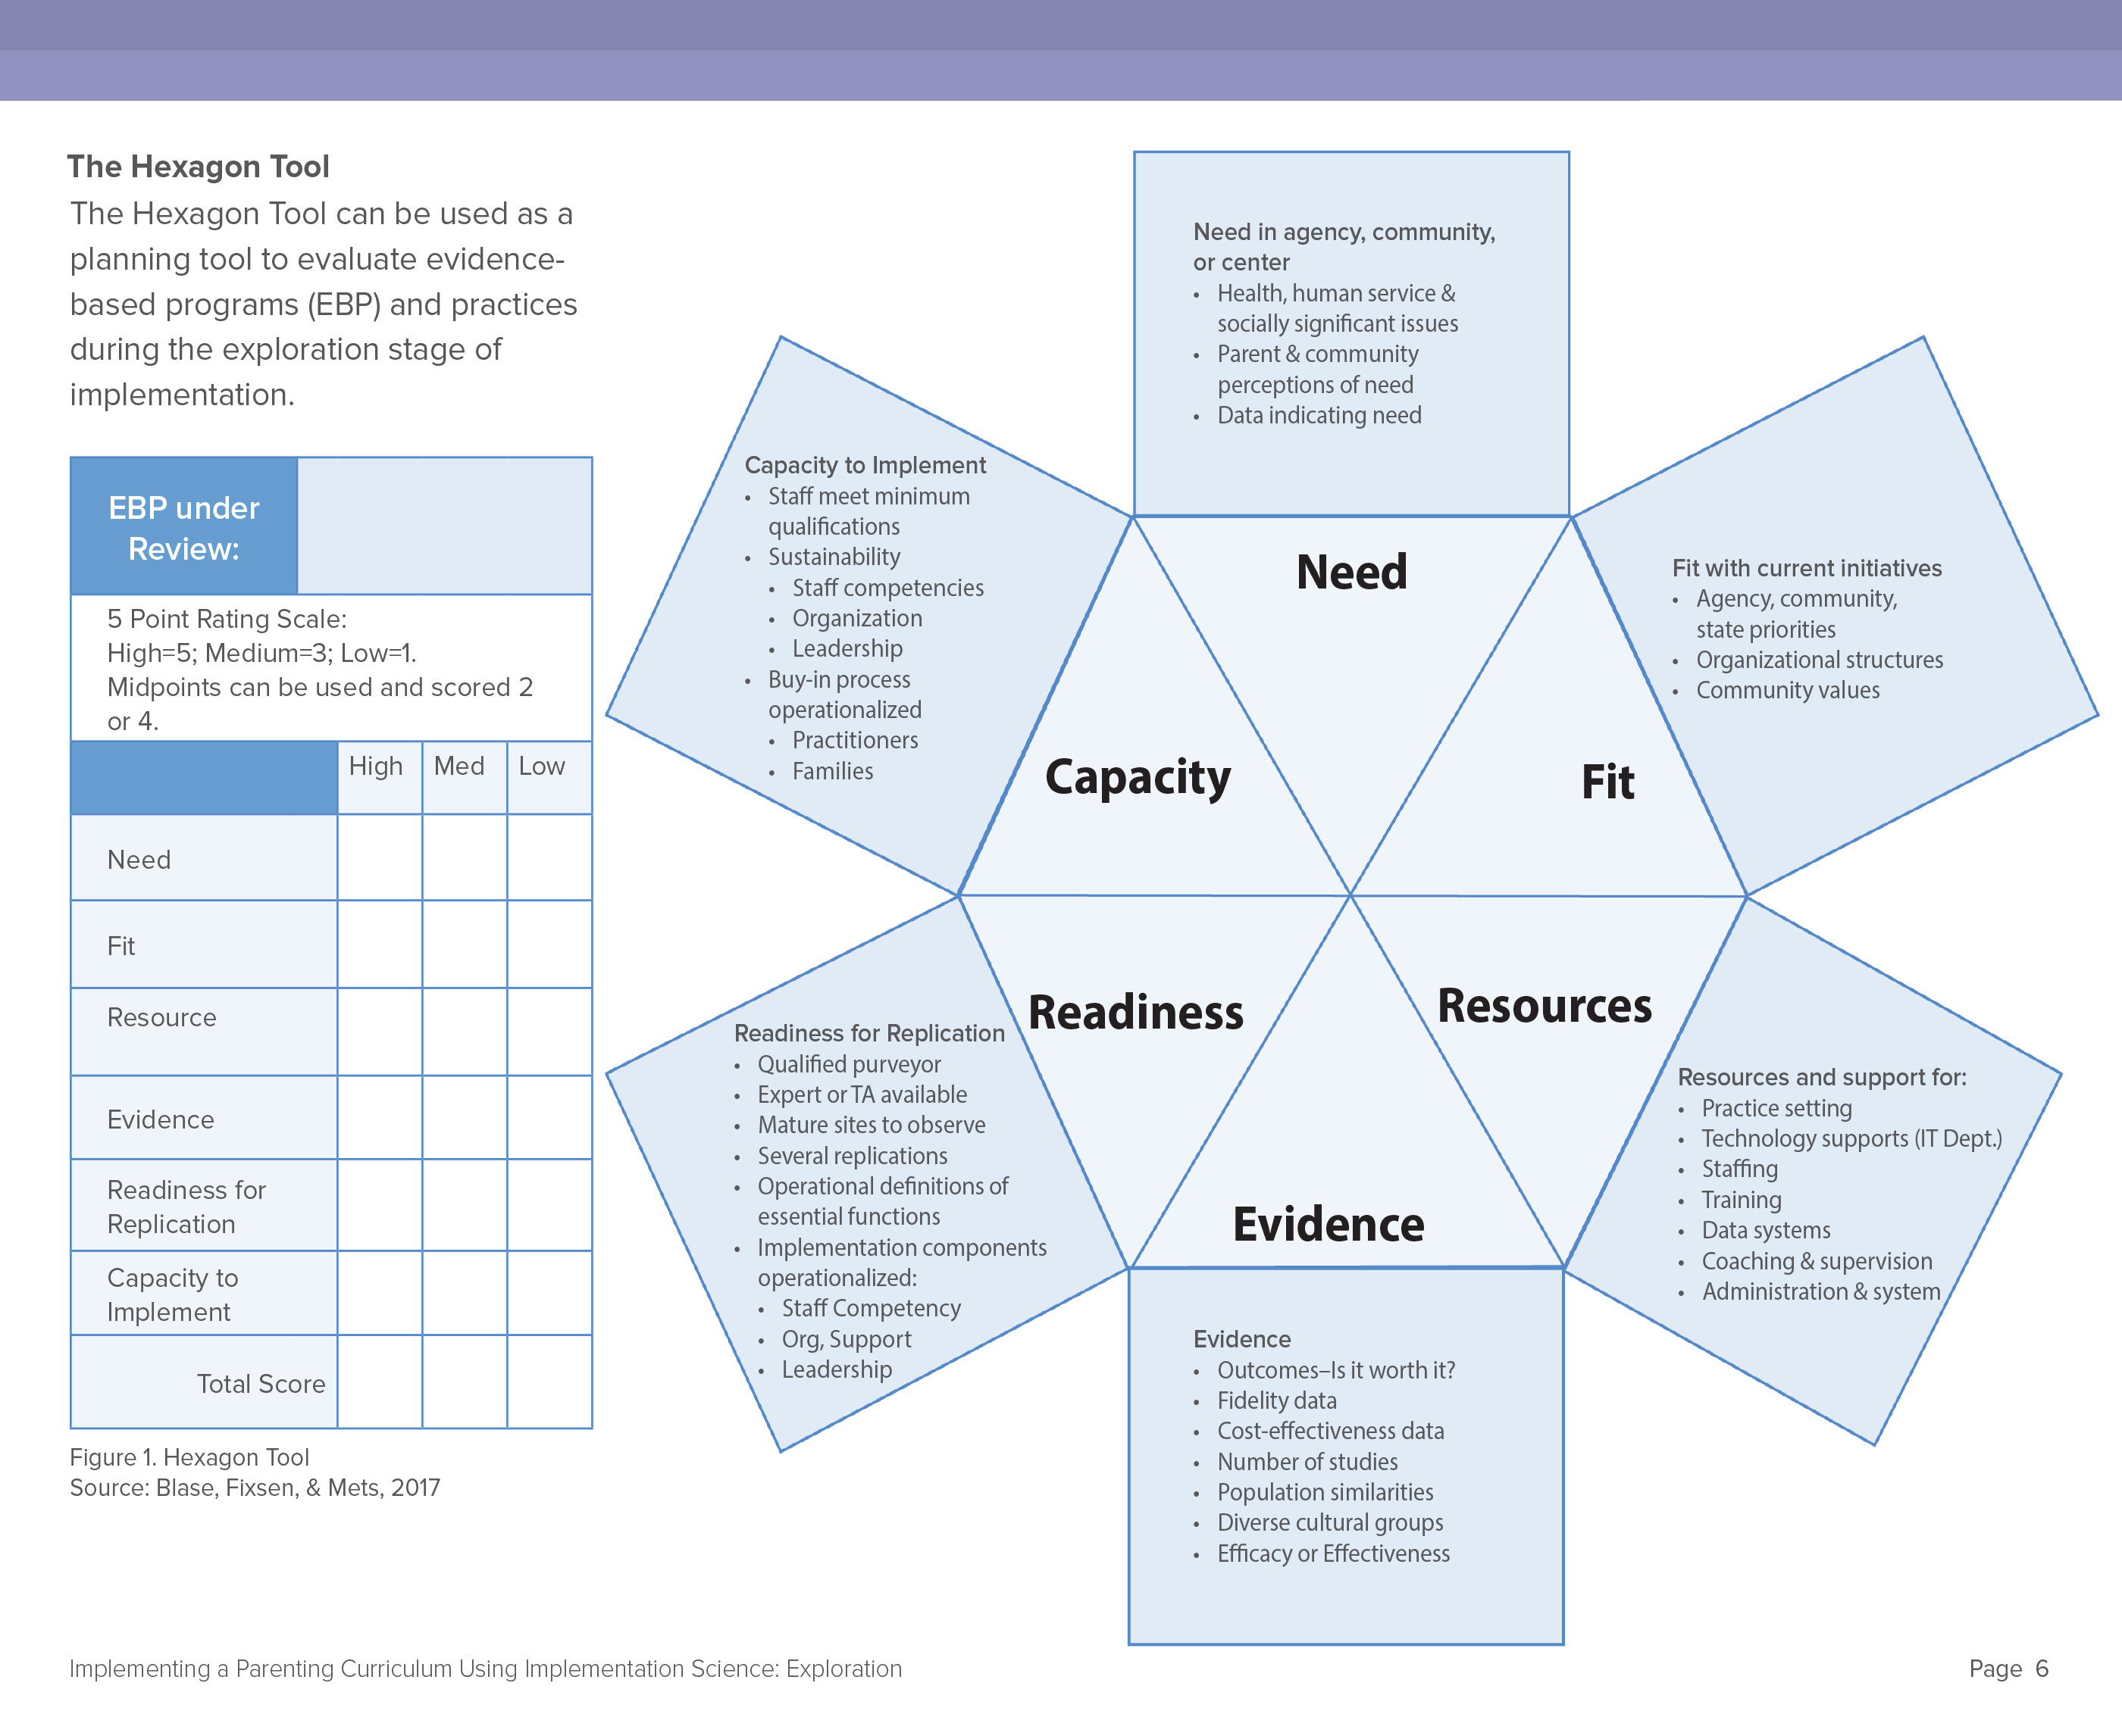

Need | Rate 1-5 | Notes (e.g. How was this determined? Is there a documented process?)
- Was an analysis of data (e.g. outcomes)
conducted to identify specific area of
need(s)?
- Is there evidence that the EBP
addresses the specific areas of need
identified?
- Is there evidence that the EBP addresses the level(s) of interest?
- Is there evidence that the EBP addresses the needs of all participants?
- Does it strengthen core understanding of tools/practices?

Fit | Rate 1-5 | Notes(e.g. How was this determined? Is  there a documented process?)
- How does the EBP fit with other existing
practices?
- How likely are implementation & outcomes of the EBP enhanced or
diminished as result of interactions with
other relevant EBP?
- How does it fit with programs mission?
- How does it fit with the current organizational infrastructure?
- How does it fit with community values,
including the values of diverse cultural
groups?

Resources | Rate 1-5 | Notes(e.g. How was this determined? Is  there a documented process?)
- Are there curricula and other resources related to the EBP readily available? In the language of participants?
- If so, what is the cost?
- Are staffing resources available? If yes, are they adequate?
- Are training resources available for this EBP?
- Are coaching resources available for this EBP or are others trained and have coaching skills and have time?

- Has this previously been applied to this population? What resources would be needed to do so?
Evidence | Rate 1-5 | Notes(e.g. How was this determined? Is  there a documented process?)
- Are there research data available to demonstrate the effectiveness (e.g. randomized trails, quasi-experimental designs) of this EBP with this population? If yes, provide citations or links to reports or publications.
- If so, are the differences between the experimental and control groups academically significant (e.g. effect size)?
- If research data are not available, are there evaluation data to indicate effectiveness (e.g. pre/post data, testing results, action research)? If yes, provide citations or links.
- Do the studies (research or evaluation) provide data specific to effectiveness for variety of participants (e.g. English language learners or other languages, those with disabilities, ages, etc.). If yes, include citations or links.
- Do the studies provide data specific to effectiveness for those of diverse cultural groups?
- Is there a fidelity assessment that measures provider behavior (e.g. observation of provider in the room), use of content, etc. If yes, provide citations, documents, or links to fidelity assessment info.
Readiness | Rate 1-5 | Notes(e.g. How was this determined? Is  there a documented process?)
- Is there a qualified “expert”, provider or coach that can help with implementation of EBP over time and across programs (e.g. training, coaching methods, progress monitoring, data)? If yes, list names and contact.
- Is this EBP currently in use in the region or state with demonstration of positive gains for participants? If so, where?
- Is this EBP currently in use elsewhere and showing positive gains for all participants?
- Is the EBP clearly defined (e.g. what it is, for whom it is intended)?
- Are the core features of the EBP identified, listed, named (e.g. key components of the intervention or practices that are required in order to be effective)?
Capacity | Rate 1-5 | Notes (e.g. How was this determined? Is  there a documented process?)
- Current staff/providers have the academic content knowledge needed to use the EBP to good effect for all participants?
- Current staff/providers have the knowledge and skills related to the instructional strategies needed to meet participants with other abilities and needs?
- Curriculum content and instructional strategy knowledge and capacity are adequate amongst staff/providers?

